**Cloud Native Development with Kubernetes Workshop**

**Sympoll: High Level Design**

**Team**: MTAPizza

**Members**: Roy Toledano, Idan Shalon, Ronen Gelmanovich

**What is Sympoll? 3**

**System design 4**

Key Components and Their Roles 4

Azure Kubernetes Service (AKS) 4

Kubernetes Cluster 5

Services 5

Pods 5

Deployments 5

Persistent Volumes (PV) 6

Persistent Volume Claims (PVC) 6

Explanation of the Diagram Components 7

**Use cases 8**

App User 8

Group Moderator 9

Group Admin 9

System Admin 9

**DB Structure 10**

Tables 11

1. Users 11

2. Groups 11

3. Group_Memberships 11

4. Polls 11

5. Poll_Options 11

6. Votes 11

Relationships 12

Constraints and Indexes 12

**Front End Structure 13**

Technologies and Design 13

Architecture 13

Mocks for the main pages of the application 14

1. Landing Page 14

2. Login/Signup Page 15

3. Feed Page 16

4. “Page Not Found” Page 17

5. Profile Page 18

6. Group Management Page 18

**Working practices 19**

Work management 19

Frontend board 19

Backend board 20

Project planning board 20

Workshop tasks board 21

Automation 21

Organization’s GitHub packages 22

Version Control 22

Organization’s repositories 22

# 

# 

# 

# 

# **What is Sympoll?**

Sympoll is an online surveying platform designed for optimal scalability using Kubernetes. It was developed to address the challenges of conducting effective surveys in environments where group conversations can disrupt the survey process, such as WhatsApp. Sympoll aims to provide a comprehensive solution for various survey needs, integrating a hierarchical polling system with multiple user roles and group functionalities.

Sympoll is targeted at a diverse audience, including community organizers, social planners, students, and corporate leaders, providing a streamlined and accessible platform for all types of survey needs​​.

# **System design**

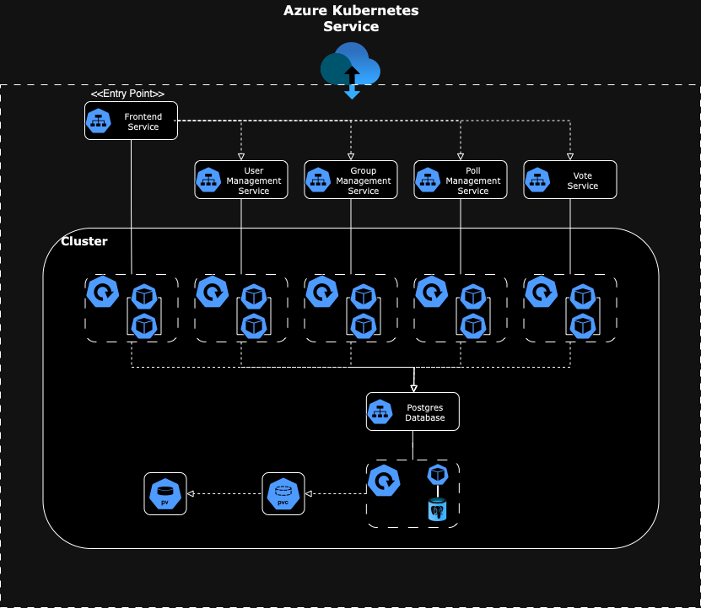

## **Key Components and Their Roles**

### **Azure Kubernetes Service (AKS)**

* **Definition:** AKS is a managed Kubernetes service offered by Microsoft Azure. It simplifies the deployment, management, and operations of Kubernetes clusters.
* **Role in Architecture:** AKS hosts and manages the Kubernetes cluster that runs the application. It handles the orchestration of containerized applications, automating tasks such as scaling, upgrades, and monitoring.

#### 

### **Kubernetes Cluster**

* **Definition:** A Kubernetes cluster is a set of node machines for running containerized applications. Each cluster has at least one worker node and is managed by a control plane.
* **Role in Architecture:** The cluster is the environment where all components (services, pods, volumes) are deployed and managed. It ensures high availability and scalability of the application.

### **Services**

* **Definition:** In Kubernetes, a Service is an abstraction that defines a logical set of pods and a policy by which to access them. Services enable network access to a dynamic set of pods.
* **Role in Architecture:** Services provide stable endpoints for accessing the microservices, even as pods are dynamically created and destroyed. They load-balance requests across the set of pods.

### **Pods**

* **Definition:** A pod is the smallest and simplest Kubernetes object. It represents a single instance of a running process in the cluster, encapsulating one or more containers.
* **Role in Architecture:** Pods host the application containers. Each microservice runs in its own set of pods, which can be replicated for scaling and fault tolerance.

### **Deployments**

* **Definition:** A Deployment in Kubernetes manages a set of identical pods. It ensures that the specified number of pods are running at all times and handles rolling updates and rollbacks.
* **Role in Architecture:** Deployments automate the creation, updating, and scaling of pods. They ensure the application runs reliably and can be updated without downtime.

### **Persistent Volumes (PV)**

* **Definition:** PVs are storage resources in the Kubernetes cluster that exist independently of the lifecycle of pods. They represent physical storage such as disks or network storage.
* **Role in Architecture:** PVs provide persistent storage that pods can use to save data. This storage remains available even if the pods using it are deleted or moved.

### **Persistent Volume Claims (PVC)**

* **Definition:** PVCs are requests for storage by a user. They specify storage requirements such as size and access modes, and they bind to an appropriate PV.
* **Role in Architecture:** PVCs allow pods to request and use persistent storage. They ensure that the right amount and type of storage is allocated to the pods.

## **Explanation of the Diagram Components**

**Entry Point:**

* **Frontend Service:**
  + **Role:** Acts as the user interface or API gateway. It handles incoming requests from users or other systems, routes them to the appropriate web page, and communicates with the appropriate backend services to pull/push data from the database.

**Microservices:**

* **User Management Service:**
  + **Role:** Manages user-related functionalities, such as user registration, authentication, and profile management.
  + **Interaction:** Receives requests from the frontend service and interacts with the database to store and retrieve user data.
* **Group Management Service:**
  + **Role:** Manages groups within the application, such as creating, updating, and deleting groups.
  + **Interaction:** Communicates with the database to manage group-related data and receives requests routed through the frontend service.
* **Poll Management Service:**
  + **Role:** Handles the creation, updating, and management of polls.
  + **Interaction:** Interfaces with the database to store poll data and processes requests from the frontend service.
* **Vote Service:**
  + **Role:** Manages the voting process within the application, including casting votes and tallying results.
  + **Interaction:** Interacts with the poll management service and the database to record and retrieve vote data.

# **Use cases**

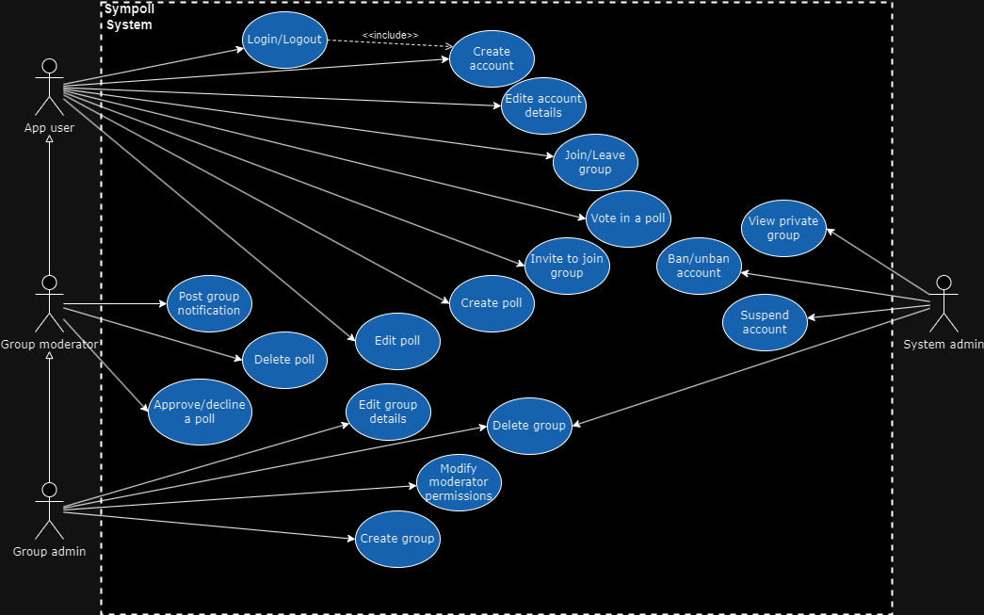

## **App User**

The standard app user which has access to all basic functionalities of Sympoll.

* **Create account:** Users can register for a new account or use an existing account from a 3rd party such as Google.
* **Login/Logout:** Log into and out of the application. This can be done with either an account created directly with Sympoll or a 3rd party account authentication service.
* **Edit account details:** Update your profile information (e.g nickname, profile photo, profile public visibility etc).
* **Join/Leave group:** Join or leave groups within the application.
* **Vote in a poll:** Participate in polls by casting your votes.
* **Invite to join a group:** Invite others to join a group.

### 

## **Group Moderator**

A role within a specific group granted to a user by the group admin. Has all privileges of the standard user but has access to some elevated permissions within the group he is moderating.

* **Post Group Notification:** Post notifications to group members.
* **Approve/Decline a Poll:** Approve or reject polls created within the group.
* **Delete Poll:** Remove polls from the group.

## **Group Admin**

This role is granted to a user either by creating a group or being appointed by its creator. It includes all duties of a group moderator along with the added authority of administering the group at the highest level.

* **Edit Group Details:** Update the group’s information (e.g name, details, rules etc).
* **Delete Group:** Delete the group you are administering from the application.
* **Modify Moderator Permissions:** Change the permissions of group moderators allowing them more or less privileges.

## **System Admin**

This role can only be granted by the application developers. It is not a standard app user, meaning it cannot participate in groups or polls. Its purpose is to help developers with moderating the system.

* **View Private Group**: System admins can view the details of private groups.
* **Ban/Unban Account:** System admins can restrict or restore user access.
* **Suspend Account:** System admins can temporarily disable user accounts.

# **DB Structure**

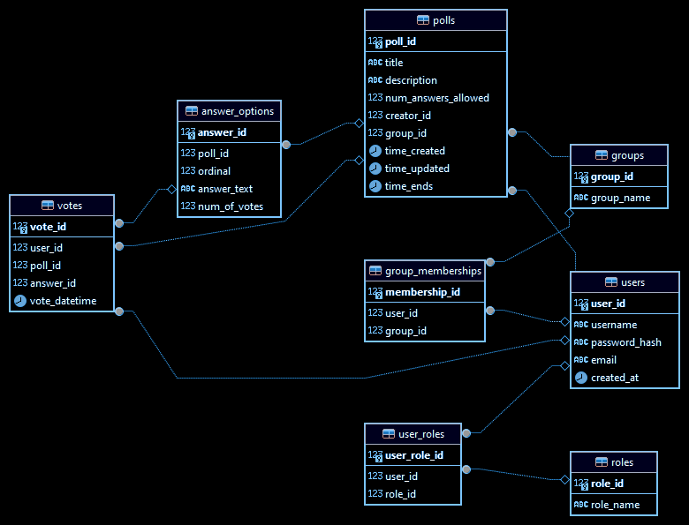

The database schema for Sympoll is designed to support the various functionalities and interactions within the application. It includes several key tables, each with specific roles and relationships. Below is an overview of the main components of the database schema.

## 

## 

## 

## 

## **Tables**

### **Users**

* + **Columns:** user_id (PK), username, password_hash, email, role, created_at, updated_at
  + **Description:** Stores information about each user, including their login credentials, role within the system (e.g., standard user, group moderator, group admin, system admin), and timestamps for account creation and updates.

### **Groups**

* + **Columns:** group_id (PK), group_name, description, created_by (FK), created_at, updated_at
  + **Description:** Contains details about each group, such as the group's name, a description, the user who created the group, and timestamps for creation and updates.

### **Group_Memberships**

* + **Columns:** membership_id (PK), group_id (FK), user_id (FK), role, joined_at
  + **Description:** Manages the membership of users in groups, indicating which users belong to which groups and their roles within those groups (e.g., member, moderator, admin).

### **Polls**

* + **Columns:** poll_id (PK), group_id (FK), created_by (FK), question, created_at, updated_at
  + **Description:** Stores the polls created within the application, including the group they belong to, the user who created the poll, the poll question, and timestamps for creation and updates.

### **Poll_Options**

* + **Columns:** option_id (PK), poll_id (FK), option_text
  + **Description:** Lists the different options available for each poll, linking them to the corresponding poll.

### **Votes**

* + **Columns:** vote_id (PK), poll_id (FK), option_id (FK), user_id (FK), voted_at
  + **Description:** Records the votes cast by users, including which option they chose and the timestamp of the vote.

## 

## **Relationships**

* **Users to Groups:** A many-to-many relationship managed by the Group_Memberships table, allowing users to join multiple groups and each group to have multiple users.
* **Groups to Polls:** A one-to-many relationship, where each group can have multiple polls.
* **Polls to Poll_Options:** A one-to-many relationship, where each poll can have multiple options.
* **Users to Votes:** A many-to-many relationship managed by the Votes table, where users can vote on multiple polls and each poll can receive votes from multiple users.

## **Constraints and Indexes**

* **Primary Keys (PK):** Ensure the uniqueness of records in each table.
* **Foreign Keys (FK):** Maintain referential integrity between related tables (e.g., created_by in Groups references user_id in Users).
* **Indexes:** Improve query performance, especially on columns that are frequently searched or used in joins, such as user_id, group_id, and poll_id.

This schema supports the core functionalities of Sympoll, including user management, group management, poll creation, and voting, while ensuring data integrity and performance.

The DB runs on a Postgresql container. We chose this platform because it is an industry standard utilized in many large scale products.

# **Front End Structure**

## **Technologies and Design**

* **Programming Language:** The frontend of the Sympoll application is developed using TypeScript, a strongly typed superset of JavaScript that ensures better maintainability and development efficiency.
* **Library:** The React library is utilized for building the user interface, providing a component-based architecture that enhances the development process and user experience.
* **Build Tool:** Vite is employed as the build tool, offering fast build times and an optimized development environment.
* **Styling:** CSS styling is managed using SASS, a CSS extension language that allows for more powerful and flexible stylesheet management.

## **Architecture**

* **Single Page Application (SPA):** Using React, the application runs within a single HTML page. The content is dynamically updated as the user interacts with the application, providing a seamless user experience without the need for full-page reloads.
* **Component-Based Structure:** The web application is divided into multiple page components, each composed of smaller reusable micro-components. This modular approach facilitates easier maintenance and scalability.
* **Role-Based Pages:** Certain pages are restricted to specific user roles such as system admins and moderators. These pages provide functionalities to manage the system and its contents effectively.
* **User Access Control:** Standard users can access only the groups they have joined, enabling them to interact with the content (polls and posts) within those groups.

## **Mocks for the main pages of the application**

### Landing Page

The welcome page of the app. From this page the user may choose to sign-in or sign-up to start using the app.

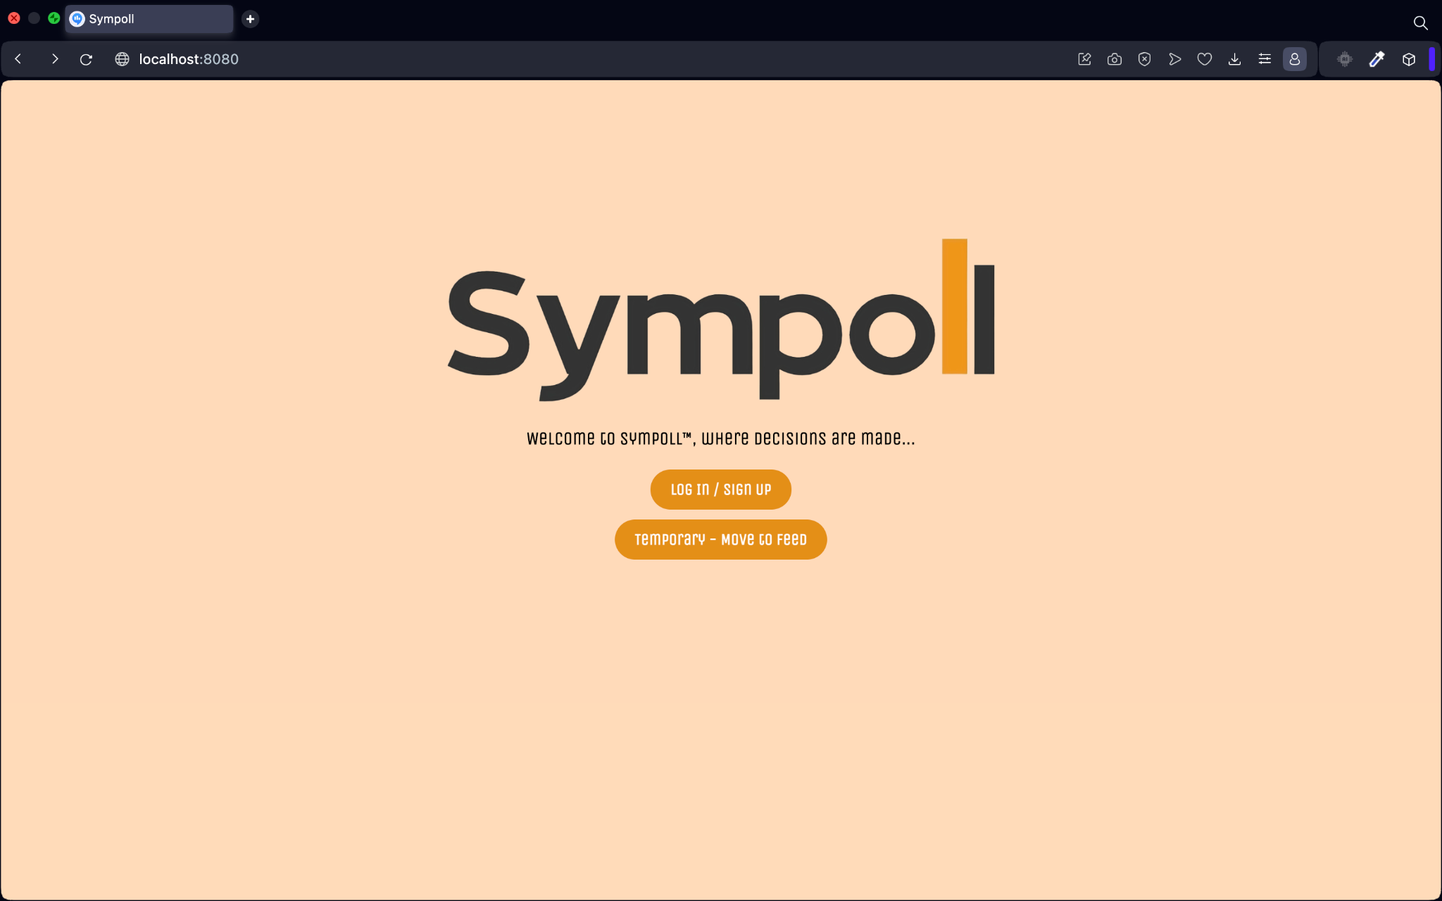

### Login/Signup Page

The user may choose to sign-in into an existing account using his username and password, or create a new account choosing a new unique username, a password and with his email. The user may switch between sign-in and sign-up using the hyperlink in the bottom of the form.

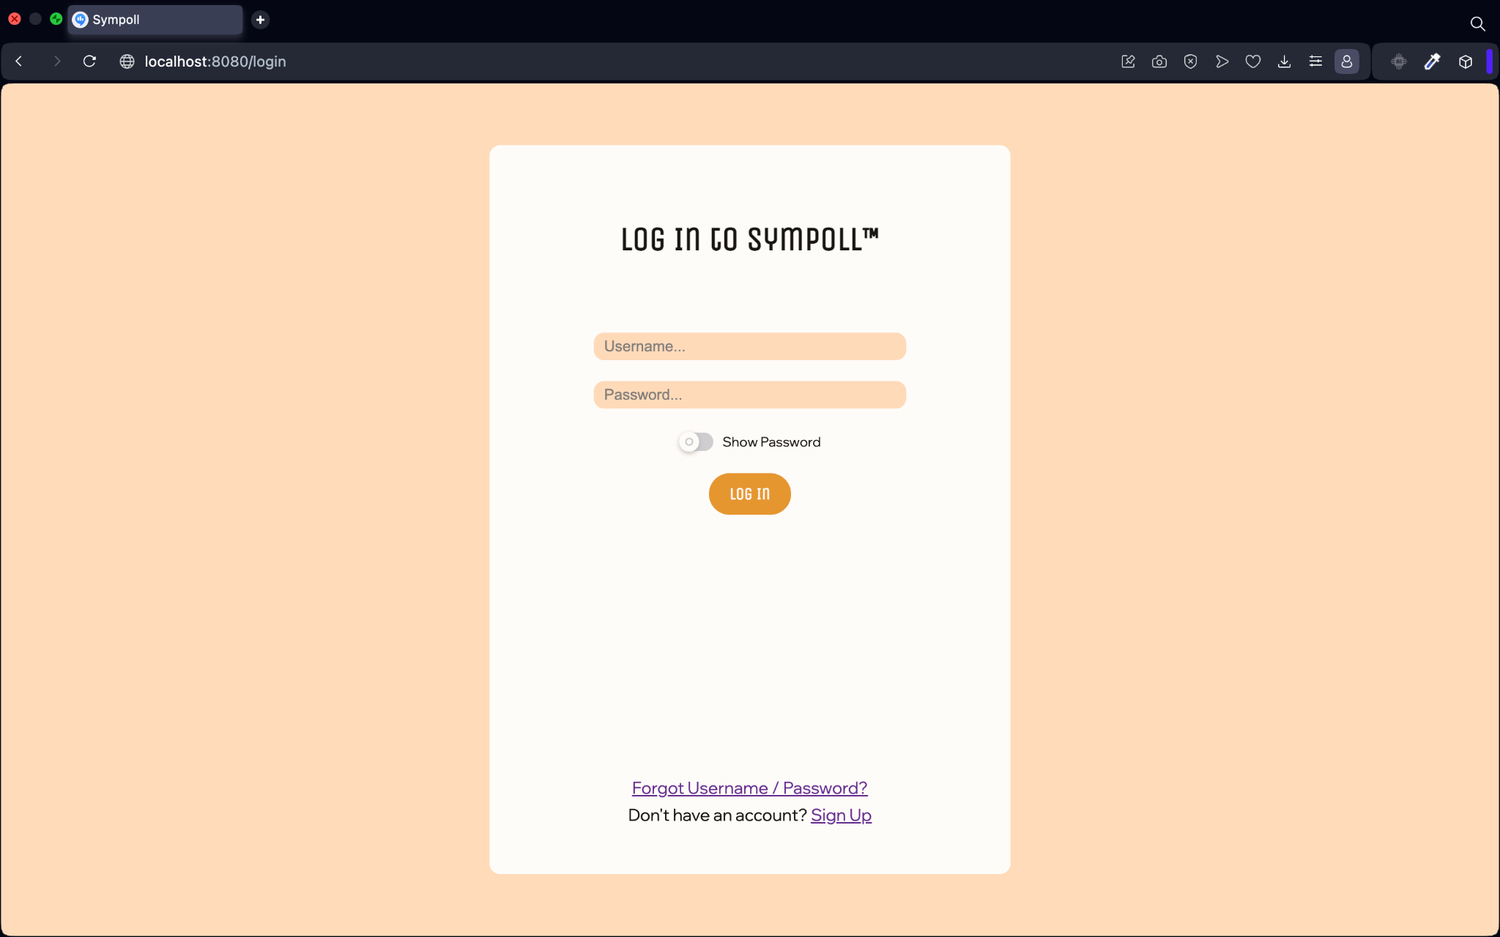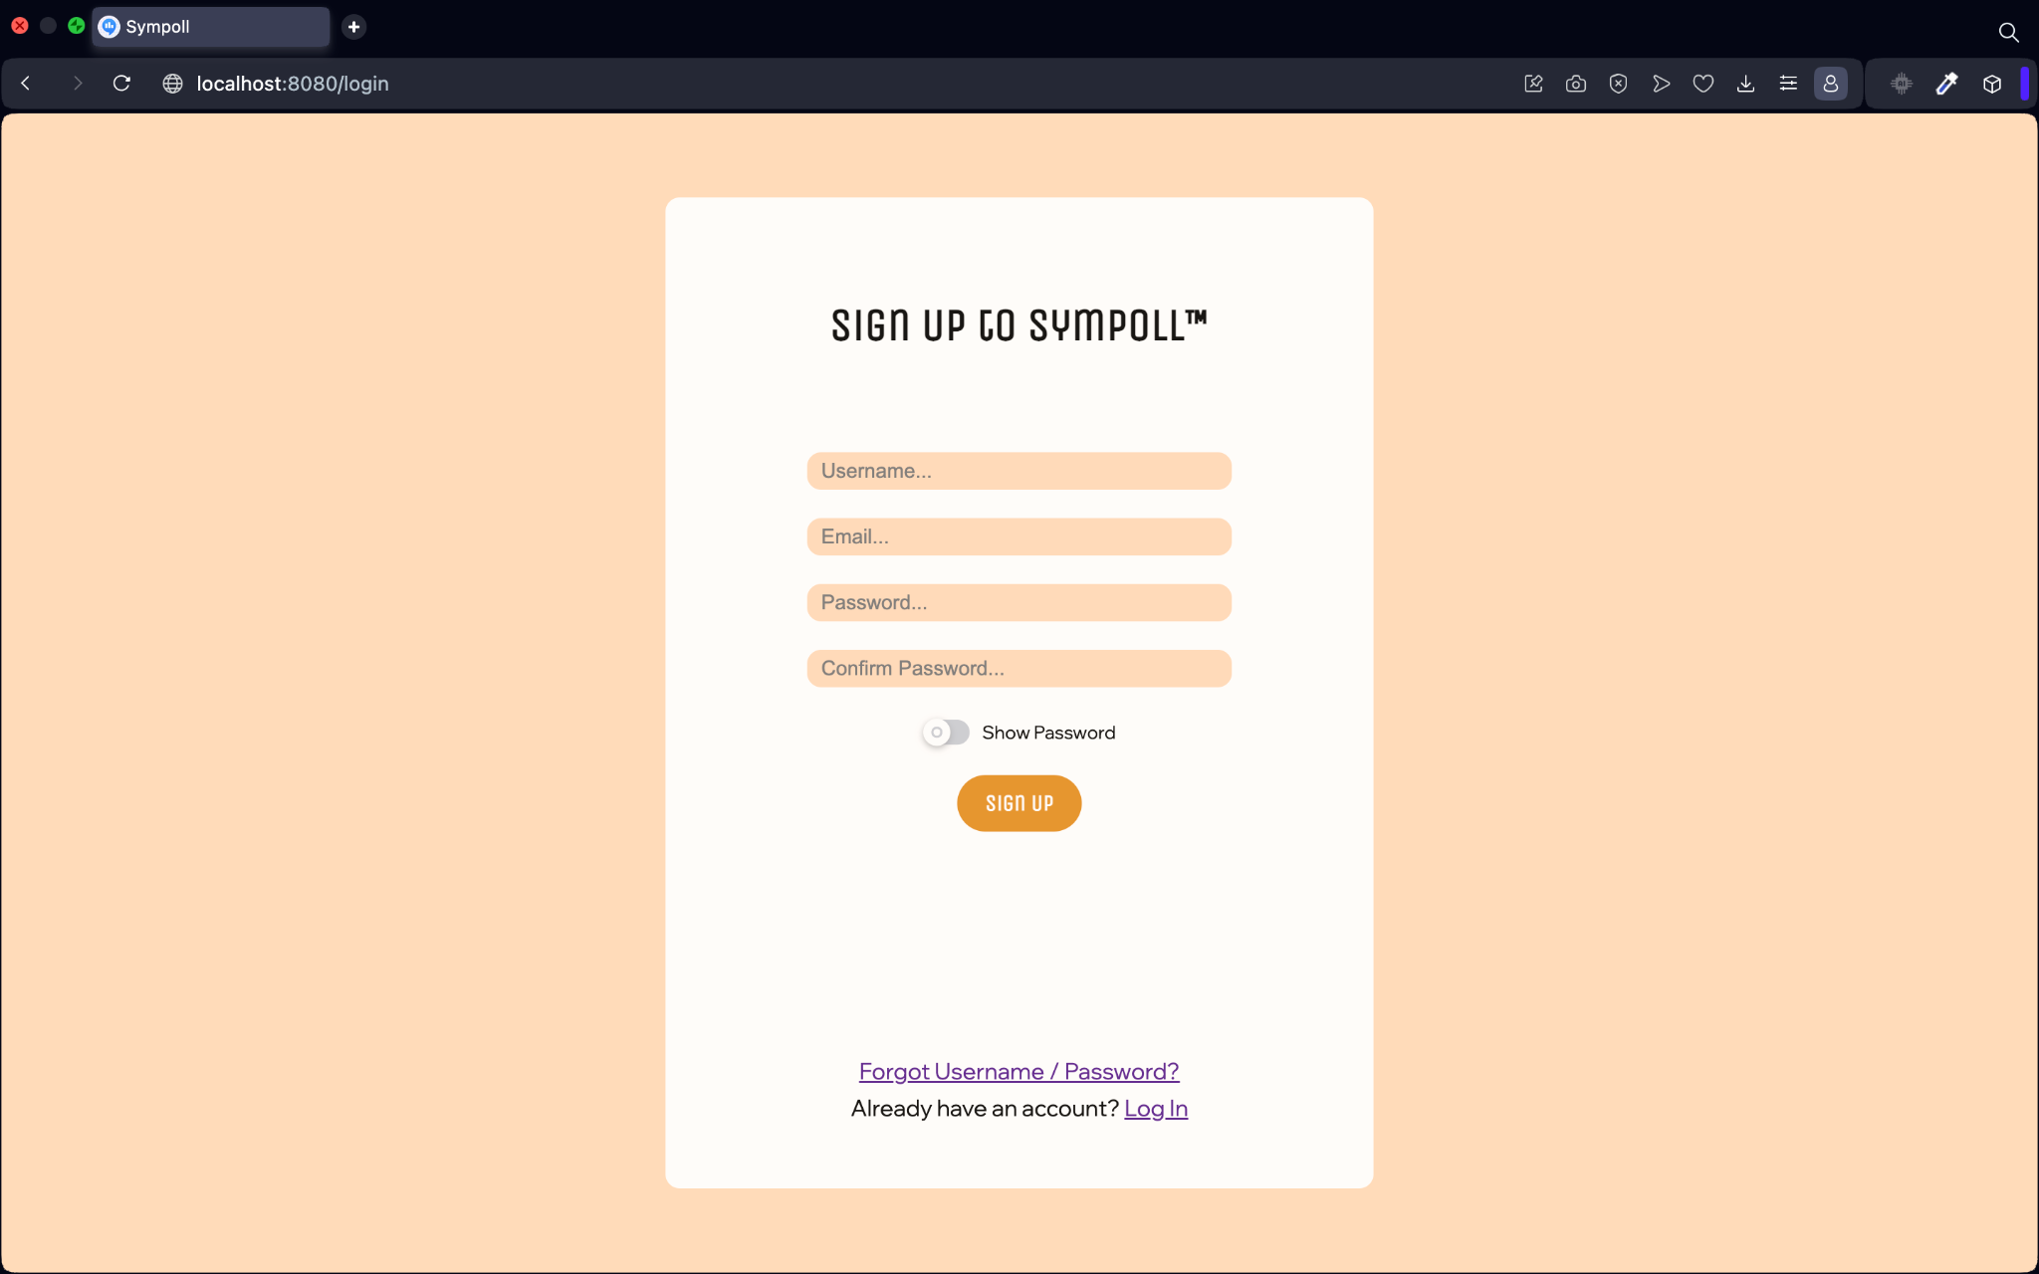

### 

### Feed Page

This is the main page of the application, where the user may view his voting groups, view the chosen group’s members (other users), vote on polls and more, in a scrollable feed, the most recent polls will be on top.

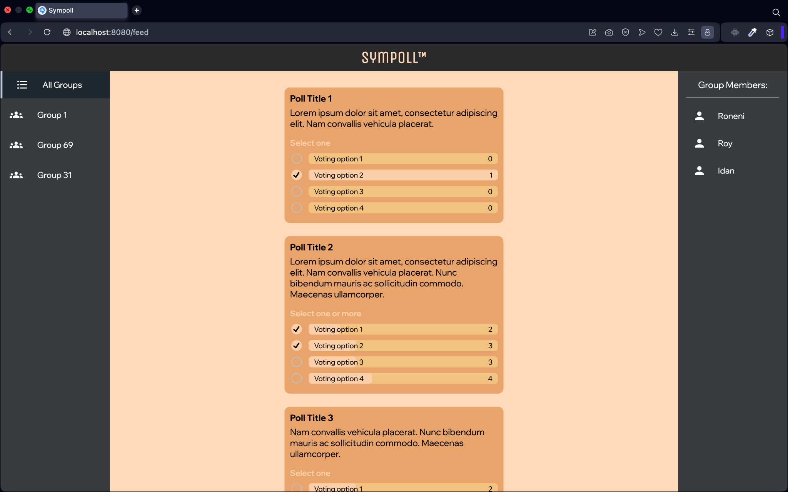

### “Page Not Found” Page

When a user enters a wrong endpoint such as “reset-account”, that there is no existing page of its name, the user will enter this page, that contains an option to return to the Landing Page.

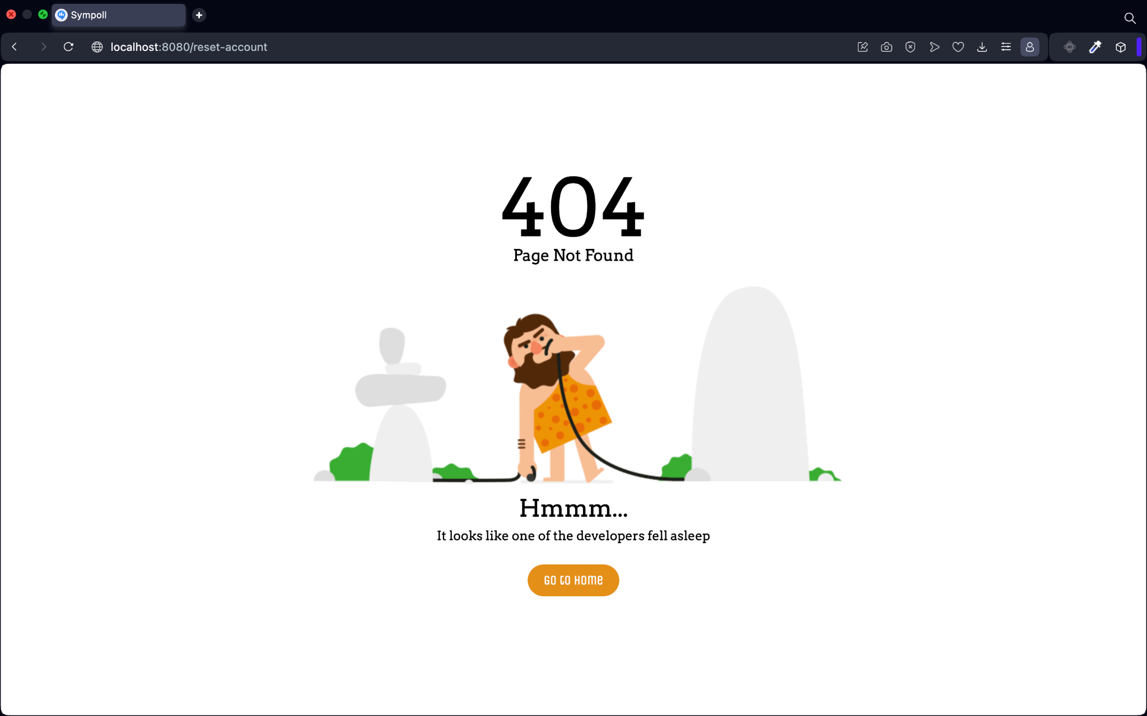

### Profile Page

Includes all information about the user’s account - Email, profile picture, full name, with an option to edit, update, and logout.

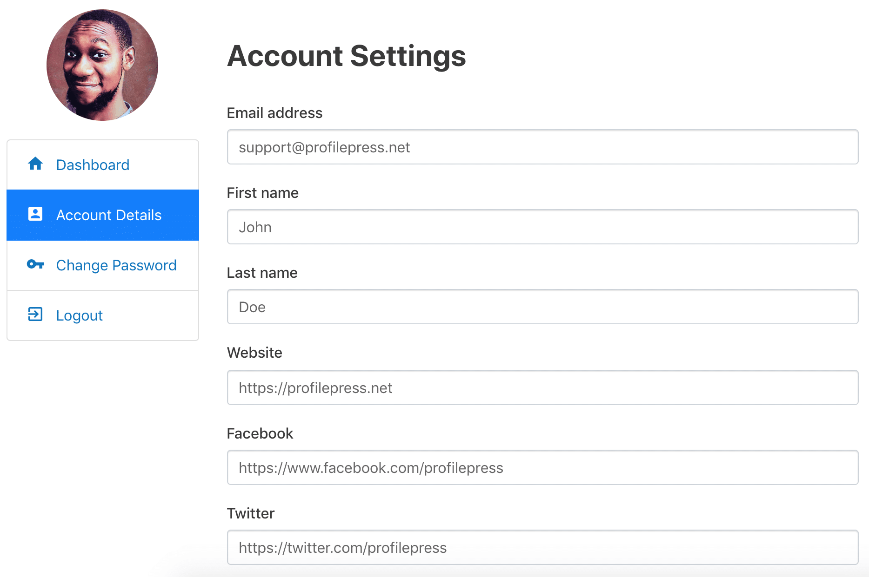

### Group Management Page

Where a group admin / moderator can edit the group’s info, add/remove members, change the group’s settings and behavior etc.

# 

# **Working practices**

## **Work management**

Project management and planning are conducted using Trello, an online kanban-style, list-making application. Our team utilizes Trello to create a workspace that currently includes four boards:

* **Backend**: Tasks related to backend development.
* **Frontend**: Tasks related to frontend development.
* **Project Planning**: Tasks that involve deciding on future steps for the project, including the selection of frameworks and technologies.
* **Workshop Tasks**: Tasks related to the workshop documents and presentations that we need to submit.

Within each board, team members assign tasks to themselves and others, and add tasks, bugs, and ideas to be addressed.

### **Frontend board**

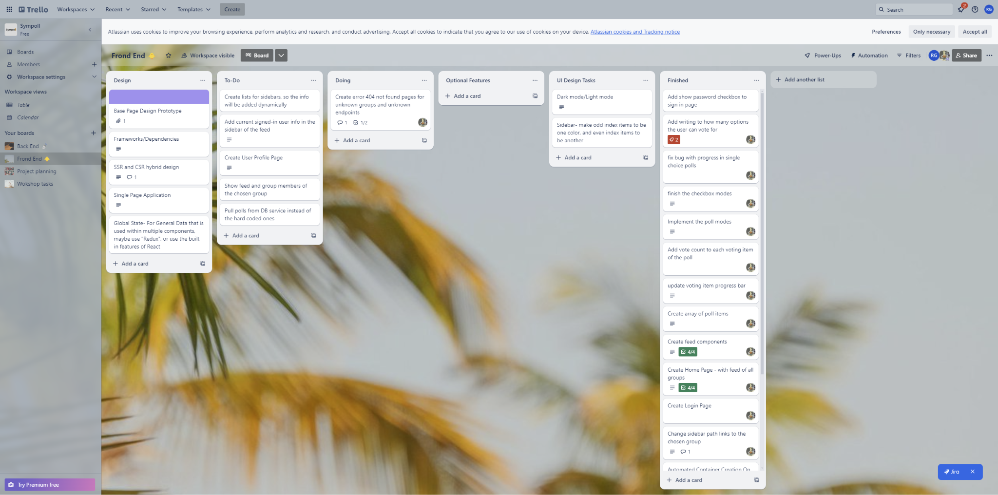

### **Backend board**

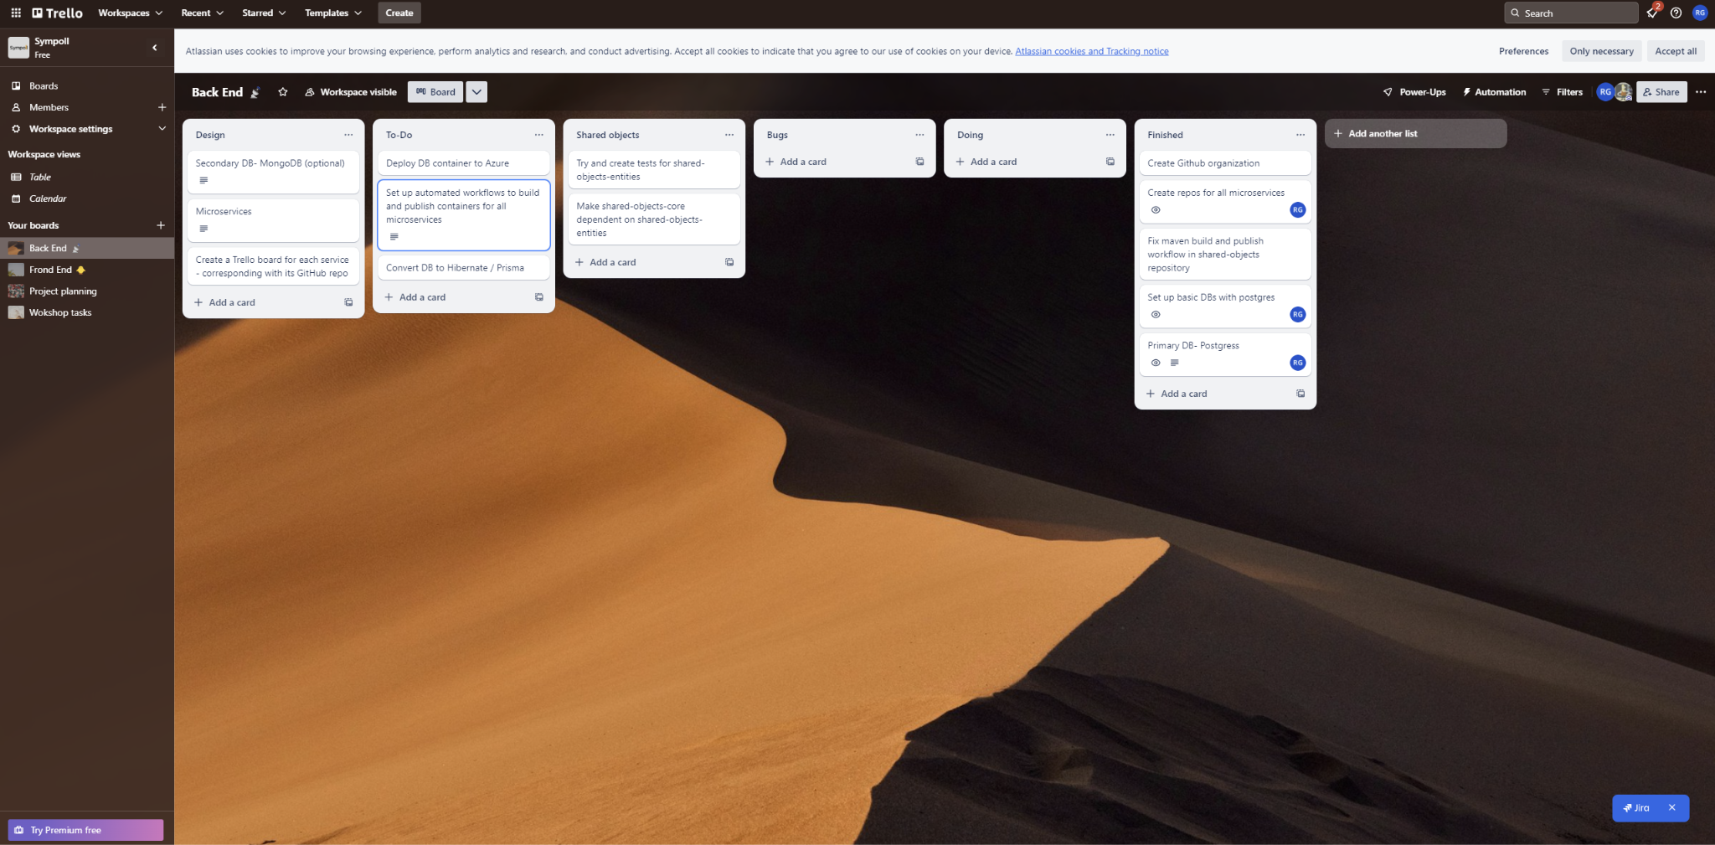

### **Project planning board**

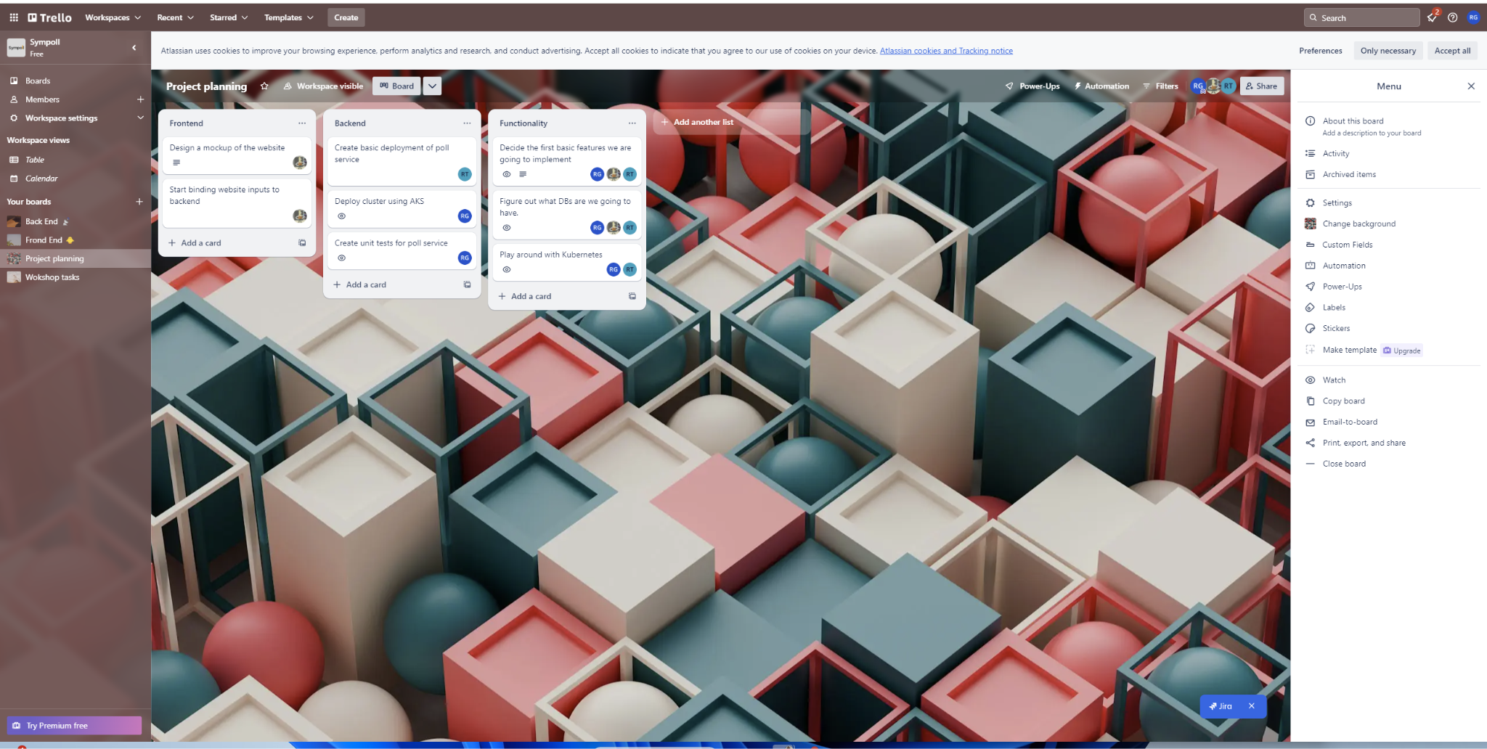

### **Workshop tasks board**

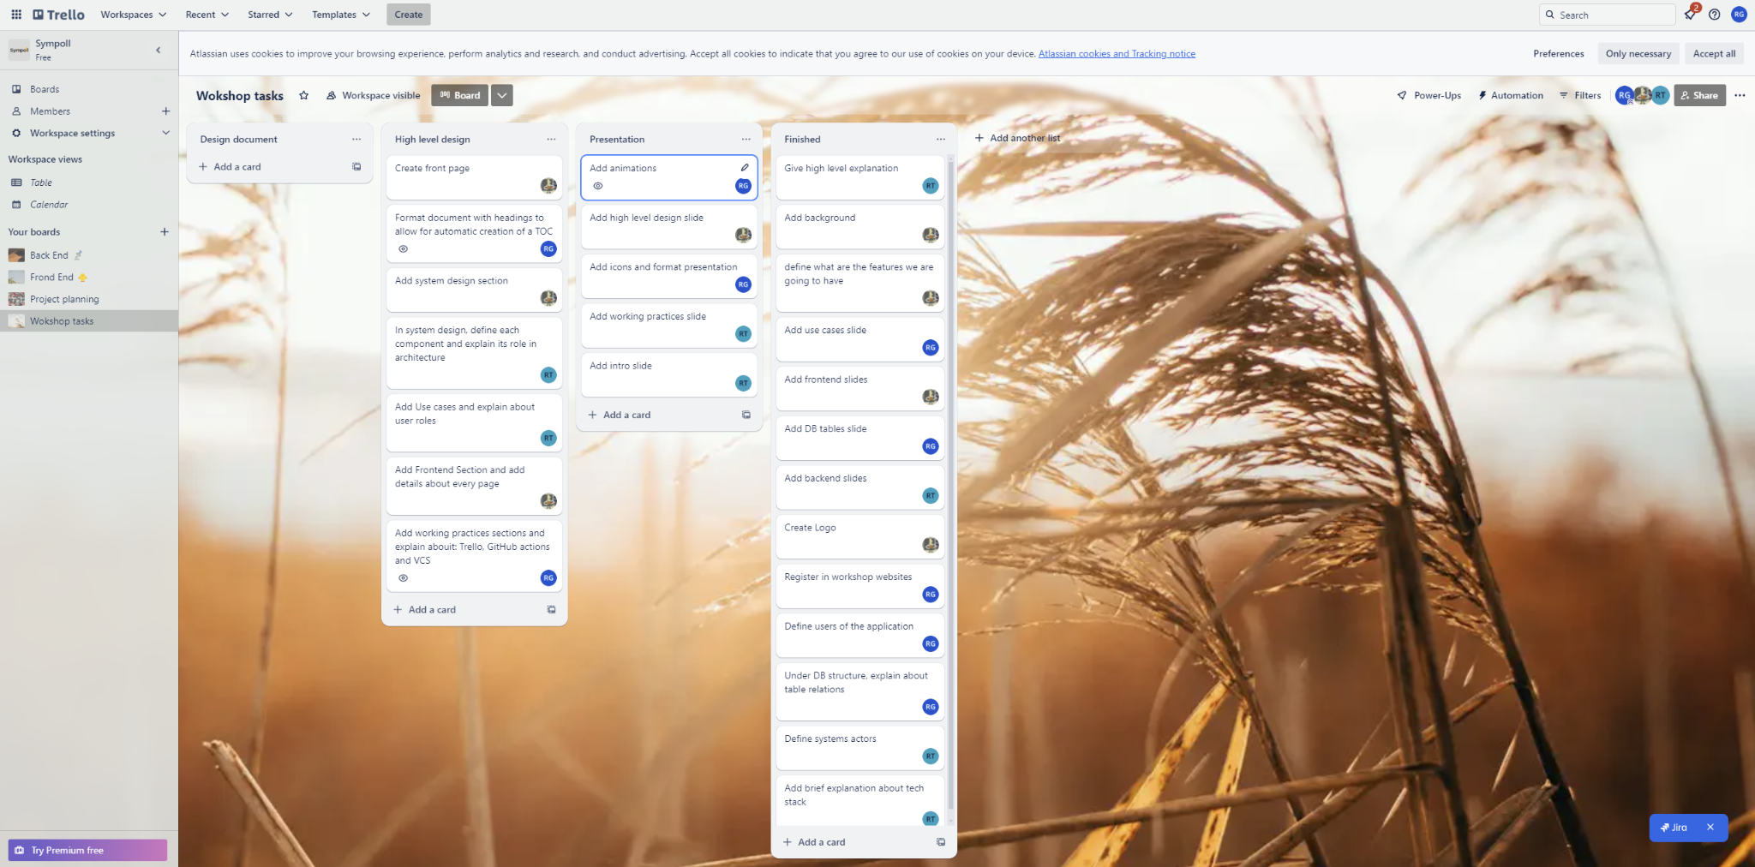

## **Automation**

* **Continuous Integration/Continuous Deployment (CI/CD):** A service’s container image is automatically created upon a push to the main branch in the GitHub repository. This automation accelerates the development process and ensures that changes are quickly integrated and deployed.
* **GitHub Actions:** We utilize GitHub Actions to automate the build and deployment process. GitHub Actions allows us to define workflows that can build, test, and deploy code directly from the repository. This ensures that every code change is verified and ready for deployment. GitHub actions provides a robust set of features for its free plan allowing us to incorporate in the future:
* Automated Testing: Integrating unit tests, integration tests, and end-to-end tests into the CI/CD pipeline to ensure code quality and functionality.
* Code Quality Checks: Implementing tools for static code analysis and style checks to maintain code standards and prevent issues early in the development process.
* Security Scans: Adding security scanning tools to identify vulnerabilities in dependencies and code.

### **Organization’s GitHub packages**

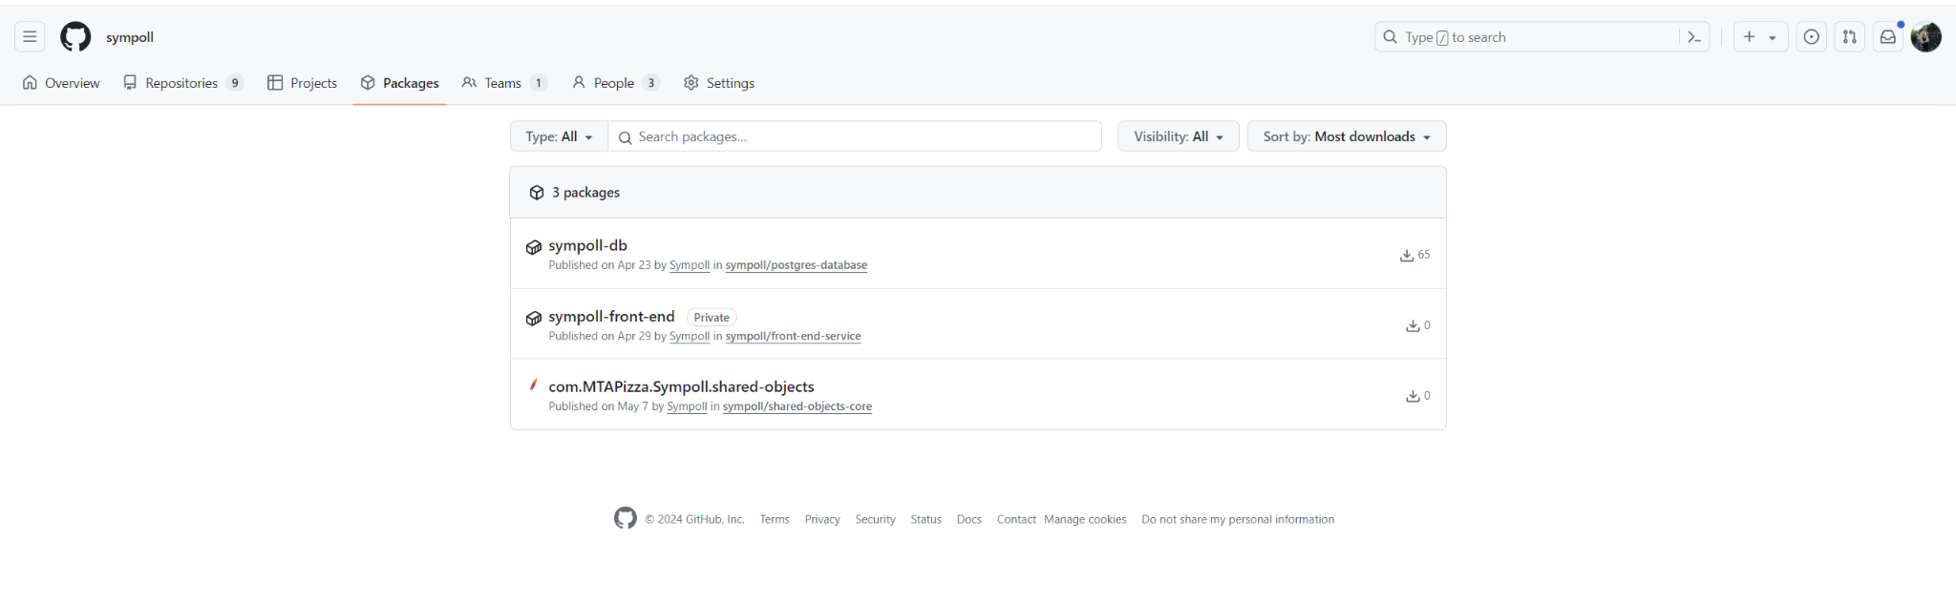

## 

## **Version Control**

* **Repository Management:** Each service has its own repository, and all repositories are managed under a GitHub organization. This structure enables better organization and management of the codebase.
* **Release Process:** A release requires the approval of at least one other team member, ensuring that changes are peer-reviewed and meet quality standards.
* **Versioning:** Each release is tagged with a version for ease of rollback if necessary. This practice helps maintain stability and allows for quick recovery in case of issues with new releases.

### **Organization’s repositories**

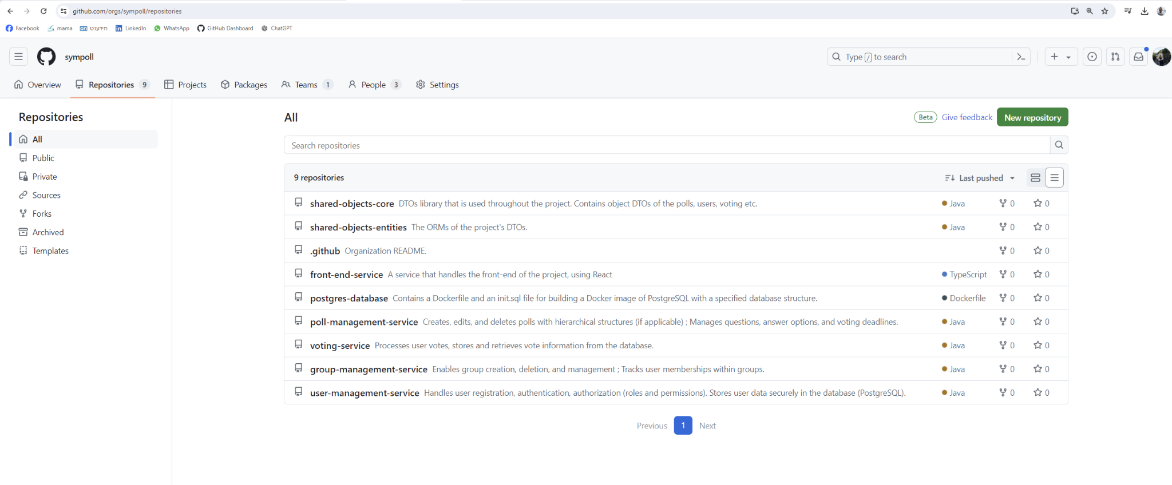

**Frontend service’s containers tagged with creation date (version)**

